**Software Requirement Specification (SRS)**

**For**

**Online Blood Bank Management System**



**Prepared by:**

**Satyam Mishra**

**Venu**

**Priti singh**

**MCA(1st Year)**

**TABLE OF CONTENTS**

## Table of Contents Revised History

1. **Introduction**
   1. Purpose 1
   2. Document convention 1
   3. Intended audience and reading suggestion… 1
   4. Product scope 2
   5. References 2
2. General descriptions
   1. Overall Description 3
   2. Product perspective 3
   3. Product function 4
   4. User classes and characteristics 4
   5. Operating environment 4
   6. User documentation 5
   7. Assumption and dependencies 5
3. External interface requirements
   1. User interfaces 6
   2. Hardware interfaces 6
   3. Software interfaces 6
   4. Communication interfaces 6
4. System features
   1. system feature 1 7
   2. system feature 2 (and so on) 8
5. Other non-functional requirements
   1. Performance requirements 9
   2. Safety requirements 9
   3. Security requirements 10
   4. Software quality attributes 10
6. **Other requirements**

## 1. INTRODUCTION

* The project online blood bank management system is known to be a pilot project that is designed for the blood bank to gather blood from various sources and distribute it to the needy people who have high Requirements for it.
* The Software is designed to handle the daily transaction of the blood bank and Search the details when required.
* It also helps to register the details of donors, blood collection details as well as blood issued reports.
* The software Application is designed in such a manner that it can suit the needs of all the blood bank requirements in the course of future.
* It will help us to find the Blood group with its most efficient time to take care of the blood and it is more easy to hand over the blood to the hospital to help people to get blood on time.
* This all thing is been stored and been seen in this blood bank management system. To help more people trying best to do so.

## PURPOSE

Blood Bank Management Software is designed and suitable for several Blood Bank either operating as individuals organizations or part of organizations covers all blood banking process from donors recruitment, donor management, mobile session component preparation, screening covering all test, blood stock inventory maintenance, patient registration, cross matching, patient issues etc.

## DOCUMENT CONVENTION

1. ER: Entity relationship.
2. This document will use IEEE format. For clarity, acronyms and technical jargon, deemed uncommon by the author, will be annotated and included in the glossary. The format for headings is as followed: Major headings are in bold 18pt font, and concurrent headings in bold 14 pt font. Sections are in the format of x.y, where x and y are real, positive integers.

## INTENDED AUDIENCE AND READING SUGGESTIONS

Anybody can use this blood bank management system to donor as well as who need blood e.g., Public, Hospitals, Blood Banks, etc.

## PRODUCT SCOPE

This application is built such a way that it suits for all type of blood bank in future.so every effort is taken to implement this project in this blood bank, on successful implementation in this blood bank, we can target other blood banks in the city.

Main modules of the project:

This project have the following modules, to manage all the requirements of the blood bank.

1. Blood donor details
2. Donor details
3. Recipient details
4. Blood collection details
5. Blood issued details
6. Stock details
7. Camp details
8. Reports

To manage employees in the blood bank it had the following modules:

* 1. Employee details
  2. Employee attendance details
  3. Employee salary generation
  4. Employee salary payment
  5. Report

## REFRENCES

* [**http://www.bharatbloodbank.com**](http://www.bharatbloodbank.com/)
* [**http://www.lionbloodbank.net/**](http://www.lionbloodbank.net/)

## GENERAL DESCRIPTION

* 1. **PROJECT PRESPECTIVE**
     + To provide an efficient donor and blood stock management system to the blood bank by recording the donor and blood details.
     + To improve the efficiency of blood stock management by altering the blood bank staff when the blood quantity is low it par level or when the blood stock has expired.
     + To provide pure blood with no wastage blood is been collected in different types of packs. They are double, triple, and triple (AS), Quadruple pack.
     + They provide synchronized and centralized donor and blood stock database.
     + To provide immediate storage and retrieval of data and information.

## Product Function

|  |  |  |
| --- | --- | --- |
| **Class of use cases** | **Use cases** | **Descriptions** |
| Use cases related to system authorization of system administrator | 1. Login of admin. 2. Change password of admin. | 1.Log admin into the system. 2.Change login password of the admin of the system. |
| Use cases related to registration of donor. | 1.Register the donor by himself. 2.Register the donor by system admin. | 1. store personal, contact, medical details of donors. 2. store personal, contact, medical details of donors. |
| Use cases related to system authorization of the donor. | 1. Login of donor. 2. Change password of the donor. | 1.Log donor into the system. 2.Change login password of the donors of the system. |
| Use cases related to change the registration details of donor. | 1. Change personal, contact details by the donor himself. 2. Change personal, contact details by system admin. | 1. Change personal and contact details of donors. 2. Change personal and contact details of donors. |
| Use cases related to withdraw names from the donor list. | 1. withdraw reg. details by the donor. 2. withdraw reg. details by the admin. | 1. Delete all details of an exact donors by themselves. 2. Delete all details of an exact donors by the system admin. |
| Use cases related to inform blood donation details. | Send blood donation details to the relevant donors. | Inform the requirement of the blood group to donors who has same blood group. |
| Use cases related to replace the older HC Certificates. | Replace donors’ HC Certificates. | Override the help condition report details. |

|  |  |  |
| --- | --- | --- |
| Use cases related to inform blood testing to the donor. | Send blood testing details. | Inform disease details to relevant donors.  Inform donor details who has diseases, to relevant doctors. |
| Use cases related to access the database. | Search relevant details from the database. | Search and display relevant details from the database. |
| Use cases related to print statements. | Print the list of newly registered donors, donation details and list of removed name as statements. | Print the list of newly registered donors, donation details, list of removed names of statements. |

* 1. **User Classes and Characteristics**

In here the system admin & the donor are the system users. According to my assumptions the donor who will register to the system from the website easy questions which are in English language & he/she has the ability to realize small instructions & fill the application without any errors & a small knowledge of computers to upload the health condition certificate to the systems. User is very generous to attend the donation with such a small announcement. (Email & SMS Messages).

## Operating environment

|  |  |  |
| --- | --- | --- |
| **Particulars** | **Client system** | **server system** |
| Operating system | Windows2000prof/Linux | Linux |
| Processor | Pentium 4, 1.2GHz | Pentium4, 2GHz |
| Hard Disk | 40GB | 100GB |
| RAM | 256MB | 512GB |

* 1. **Design and implementation constraints**

Who uses internet connection will be guided through small and clear descriptions. Every donor may get user name and a password in order to log into the will authenticate the accuracy of the donor’s mobile numbers through counting the numbers of characters in the entered mobile number system uses the donor registration number and the identity card number to identify each donor separately. Inside the system the administrator has more advance function than the donor. The hospital doctor is not a user of the system. But the doctor connects to the system in a different manner. The doctor mainly has the connection with the system admin

## User Documentation

For user documentation and information please consult section 4 external interface requirement and attached user manual.

## Assumptions and Dependency

There are:

* + - Every donor has a mobile phone.
    - The system doesn’t keep the details of the gathering stock of blood.
    - The system database will be accessible in real time.
    - The donor doesn’t submit any fake reports to his system.
    - The donors who want to contribute to a donation will definitely reply to the request of system.
    - The installation of the system to the website server hasn’tconsidered as a process inside the system that process will do by the authorities who controlling the website Therefore, in here the installation the process is considered as a process which is in o3utside of the scope.
    - A doctor or a patient can request for an exact blood group. But the request comes through blood bank authorities to the system admin. Therefore, doctor, patient are not directs users of the system.

## External Interface Requirement

The system is basically running on the official website of the govt, blood bank. Mainly there are 2 actors in the system. The system provides some advance features to the system admin than the donor. If the system admin logs in, the system interface provides some main command buttons to the admin.

* Change login password.
* Edit donor profile details.
* Search donors for a exact blood group and send messages.
* Print statements.
* Update the database.
* Send blood testing details.
* Search details from the database.

If the donors log in, the system will provide another different interface with different commands.

* Change login passwords.
* Edit personal .contact details
* Details related to contributions to donations.
* Future blood donation details.
* Withdraw name from the system.

## User Interfaces

It has been required that every form’s interface should e user friendly and simple to use.

## Hardware Interfaces

* + - 1GHz or High processor
    - 512 MB RAM
    - 500 MB Hard Disk

## Software Interface

Dept of CEA, GLAU, Mathura

## Smart blood bank

* + - Windows
    - Internet Explorer, Chrome, Firefox

## Communication Interface There are:

* + - Should run on 500GHz, 64MB Machine.
    - Should have a proper internet connection.
    - The response time for occurs a change will be more than 4 seconds.
    - The response time for access the database will be no more 5 seconds.

## SYSTEM FEATURES

There are:

* Donor management-donor registration, managing donor database, recording their physical and medical statistics.
* Inventory management in blood bank for storage and issuance of blood.
* Online transform of blood from one blood bank to another.
* Blood requisition and issuance of blood.
* Discarding of expired and unsuitable blood (less Qty., reactive, clotting, hemolysis).
* Being a web based system, can be implemented throughout the state. Separate users accounts can be created for each blood bank.
* Patient register/blood sample receiving register, donor register, blood issue register and discarded blood report.
* Fridge wise stock position and printing of fridge stickers.
* List of donors who are eligible for donation on a particular date with contact number.
* Camp wise donor list and printing of donor cards.

## SYSTEM FEATURE 1

* + 1. **Description and priority**
* Information of all blood banks donor details, donate blood with their interest and others will do in future.
* Interested in donating the blood can register.
* General users want to contact blood donors by checking interested to donate blood, he can also take the help of this site.
* Rapid response of urgent request for blood components.
* Checking pre-transfusion samples and request
* Assessing of Immunological compatibility between donor and patient.
* Selecting of suitable blood component of each clinical conditions.
* Safe delivery and handling of blood components.
* Inventory and stock management.
* Interactions with the blood establishment.

## Functional Requirements

* Login of admin.
* Blood Donor.
* Change the login password of admin.
* Register the donor by himself.
* Register the donor by system admin.
* Login of the donor.
* Change the login password of donor.
* Change personal, contact details by the donors himself.
* Change personal, contact details by the system admin.
* Withdraw reg. details by the donor.
* Withdraw reg. details by the admin.
* Send blood donation details to the relevant donors.
* Send blood testing details.

## SYSTEM FEATURES 2

There are some features of blood bank management system are:

* + - Generating reports on stock- blood group wise, area wise and expiry date wise.
    - Donor database-blood group wise and area wise.
    - Maintain and update unique donor identifications.
    - Track and maintain all the donor types- voluntary, exchange and directed.
    - Improved the Effectiveness and Efficiency of blood bank- faster response time and better control.
    - Accurate database/Record management.
    - Blood cross match and result storage facility.
    - Rejected donor database for donor control and identifications.
    - Blood transfusion related diseases control and preventions.
    - Searched facility for destroyed and expired blood.
    - Comprehensive donor database with search facility.
    - Unique donor ID and patient record ID for managing future list.
    - Improve blood bank processes by providing efficient and continuous software support.

## OTHER NON-FUNCTIONAL REQUIREMENTS

A Characteristics of a quality SRS is that in addition to describing the functional requirements of a system, it will also provide detailed coverage is of the non-functional requirements. In practice, this would entail detailed analysis of issues such as availability, security, usability and maintainability. However, as this document is only an outline specification, It doesn’t contain the same degree of rig our that would normally be expected in a formal SRS. Therefore, the sections below should be seen as indicative rather than providing specific (i.e. Testable) requirements.

## Performance Requirements

* + - The system is interactive and the delays involved are less.
    - When connecting to the server the delays is based editing on the distance of the two System configuration between them so there is high probability that there will be or not a successful connection in less than 20 seconds for the sake of good communications.

## Safety Requirements

Blood bank modules maintains details about the donors and recipients. These blood bank modules is linked to other modules in the software for wards and OT in the hospitals, whereby, any and all blood requirements using surgeries etc. That happens in the hospitals are known to the bank. Important information and parameters such as availability of blood, cross-matching between donor’s and recipient’s blood groups and blood transfusions reactions are recorded. Also, the interactions with other blood banks within in a hospitals or outside and delivery/recipients of blood bags between these banks or hospitals are recorded and maintained.

* + - The blood request queue screen, from where all the daily transfusions can be handled.
    - Fresh blood and stored blood request processing.
    - Blood returns is made easy in the blood bank management system.
    - Transfusion detailed and charging.
    - Destruction Details.
    - Blood bank management system is integrated with lab module for blood cross match and grouping.

## Security Requirements

* + - The system uses SSL (secured socket layers) in all transactions that include any Confidential customers Information**.**
    - The system must automatically log out all customers after a period of inactivity.

## Software Quality Attributes

The system will posses some quality attributes to the users:

1. Reliability:

The system has the ability to work all the times without failures apart from network failure. A donor can have the faith on the system. The authorities will keeps the privacy of all donors in a proper manner.

When the doctors found any disease in the testing stage after providing relevant details to the donor the system keeps the secretively of the donor.

1. Robustness:

The entire system includes every function which is always help to the system to work correctly and strongly in all conditions.

1. Interoperability:

The system UPAKARA will run on the blood bank website. Therefore the system includes the ability to work with the other applications which are also run on the same website.

## OTHER REQUIREMENTS

* Security: The system doesn’t have a tight security system. Because People who log into the system are volunteers who like to donate blood for innocent patients. But the system consists of some security features.
  + Any donor can’t see any details of any other donor.
  + If a donor doesn’t manage to provide hi user name and a password in three times the user automatically will log out from the website.

## DIAGRAMS - Blood Bank Management System

* Use case diagram
* Activity diagram
* Data flow (level 1) Diagram
* Data flow (level 0) Diagram
* E-R diagram
* Sequence Diagram

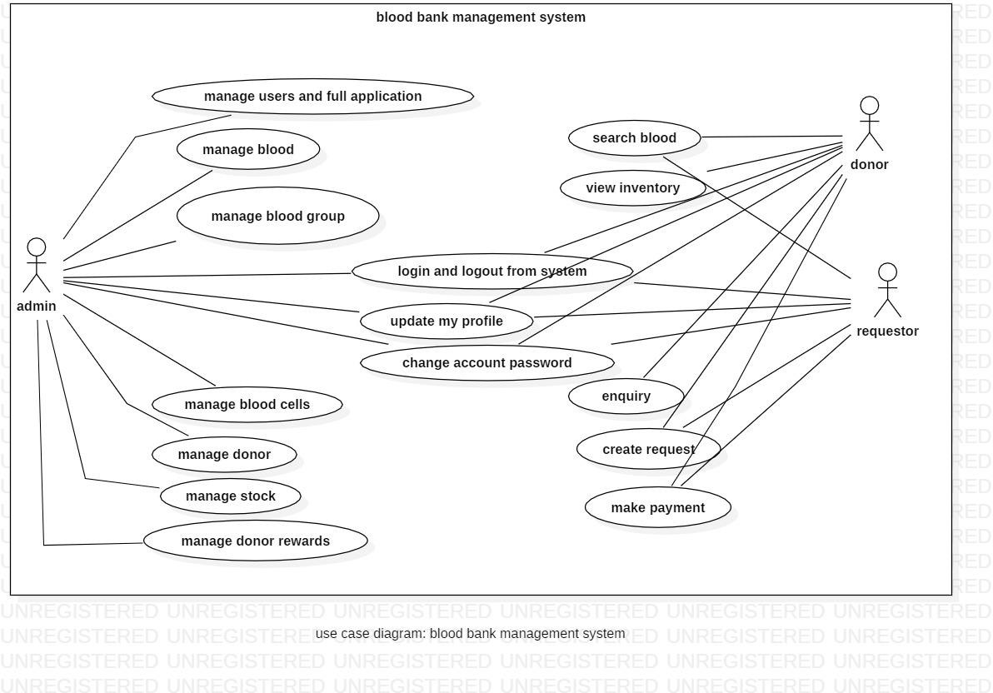

USE case of blood bank management system

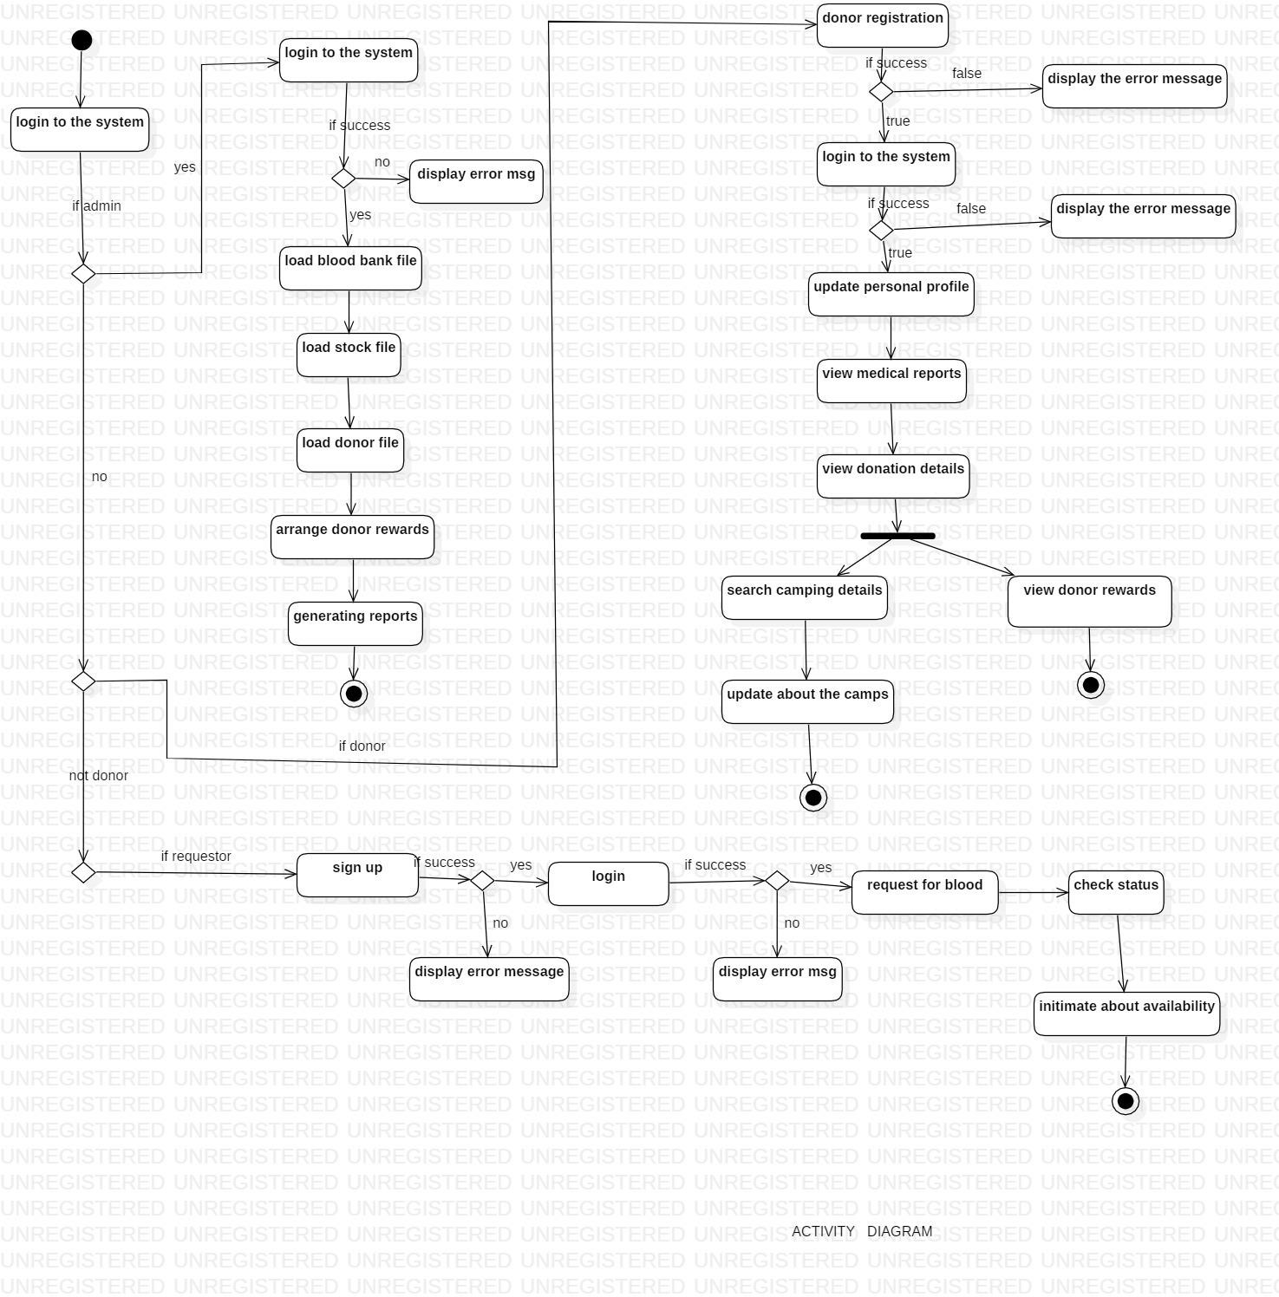

# Activity diagram of blood bank management system

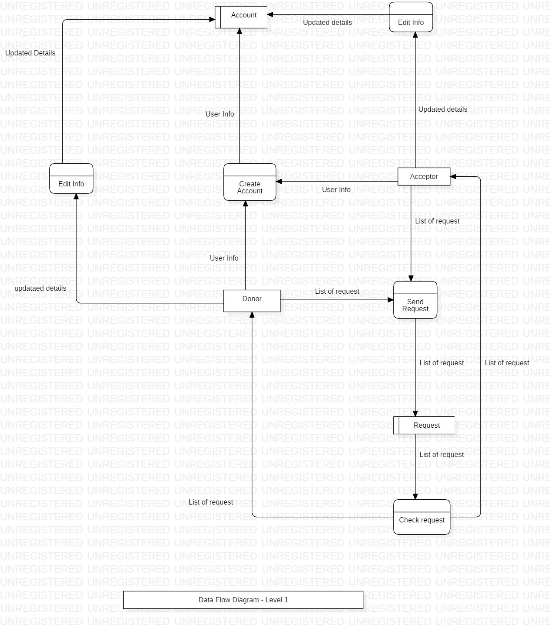

Data flow diagram (level 1)

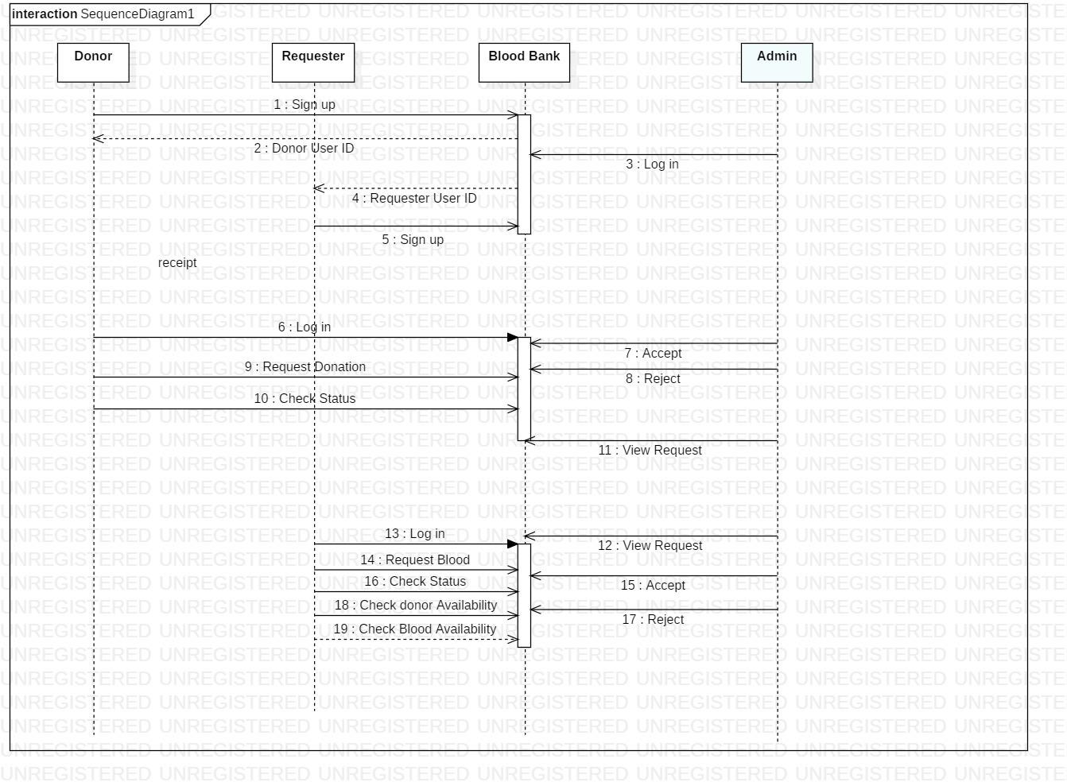

# Sequence diagram of blood bank management system